VERSACE SHOES

ARTICLE | MATERIAL | COD. COL. | COLOUR |  |  |  |  |  |  |  |  | PRICE CHOOSE |  | PRICE TAKE ALL
 |  |  |  | 39 | 40 | 41 | 42 | 43 | 44 | 45
YOBSA1 77147 | 77147 | 239 | BLUE AVIO | 24 | 32 | 24 | 32 | 28 | 32 | 21 | 193
YOBSA1 77147 | 77147 | 829 | GREY | 12 | 12 | 20 | 20 | 20 | 32 | 12 | 128
YOBSA1 77147 | 77147 | 899 | BLACK | 23 | 24 | 24 | 32 | 32 | 32 | 16 | 183
 |  |  |  |  |  |  |  |  |  |  |  | € | 45,00 | €
 |  |  |  | 39 | 40 | 41 | 42 | 43 | 44 | 45
YOBSA2 77148 | 77148 | MDV | NAVY-GREY | 40 | 28 | 87 | 114 | 111 | 50 | 36 | 466
YOBSA2 77148 | 77148 | MGI | BLACK-ARMY | 15 | 16 | 31 | 60 | 53 | 33 | 25 | 233
YOBSA2 77148 | 77148 | 899 | BLACK | 54 | 125 | 71 | 122 | 80 | 107 | 126 | 685
 |  |  |  |  |  |  |  |  |  |  |  | € | 45,00 | €
 |  |  |  | 39 | 40 | 41 | 42 | 43 | 44 | 45
YOBSB1 77149 | 77149 | MGJ | BLACK-LIME | 20 | 80 | 81 | 56 | 19 | 23 | 14 | 293
YOBSB1 77149 | 77149 | 899 | BLACK | 21 | 67 | 178 | 243 | 219 | 93 | 64 | 885
 |  |  |  |  |  |  |  |  |  |  |  | € | 48,00 | €
 |  |  |  | 39 | 40 | 41 | 42 | 43 | 44 | 45
YOBSB2 77150 | 77150 | 899 | BLACK | 23 | 22 | 66 | 53 | 1 | 14 | 26 | 205
 |  |  |  |  |  |  |  |  |  |  |  | € | 45,00 | €
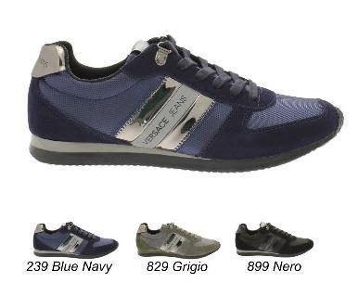
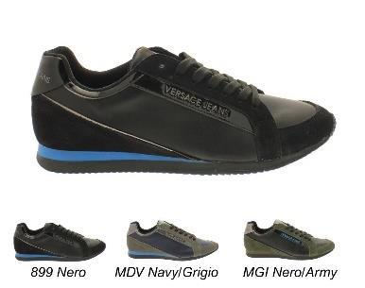
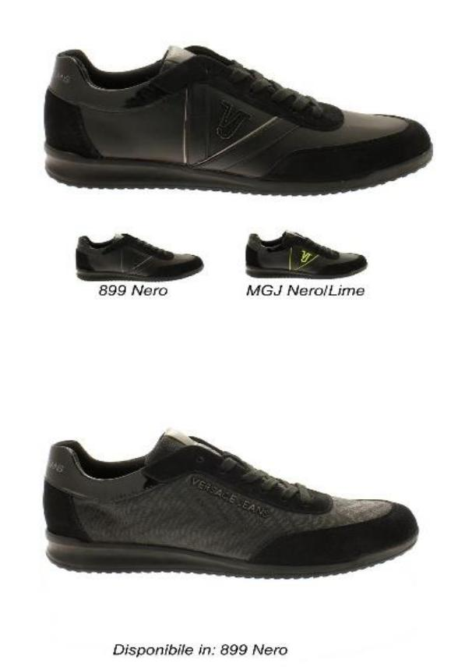
 |  |  |  | 39 | 40 | 41 | 42 | 43 | 44 | 45
YOBSB3 77160 | 77160 | 829 | GREY | 11 | 14 | 26 | 31 | 22 | 46 | 22 | 172
YOBSB3 77160 | 77160 | 899 | BLACK | 15 | 7 | 51 | 38 | 26 | 27 | 17 | 181
 |  |  |  |  |  |  |  |  |  |  |  | € | 40,50 | €
 |  |  |  | 39 | 40 | 41 | 42 | 43 | 44 | 45
YOBSC1 77151 | 77151 | MG5 | BLACK-NAVY | 11 | 16 | 26 | 34 | 22 | 46 | 22 | 177
YOBSC1 77151 | 77151 | MGI | BLACK-ARMY | 10 | 54 | 26 | 43 | 34 | 46 | 8 | 221
YOBSC1 77151 | 77151 | 899 | BLACK | 11 | 12 | 37 | 46 | 18 | 32 | 36 | 192
 |  |  |  |  |  |  |  |  |  |  |  | € | 45,00 | €
 |  |  |  | 39 | 40 | 41 | 42 | 43 | 44 | 45
YOBSD1 77152 | 77152 | 239 | NAVY | 10 | 12 | 26 | 34 | 22 | 46 | 22 | 172
YOBSD1 77152 | 77152 | 899 | NERO | 12 | 23 | 32 | 46 | 38 | 23 | 21 | 195
 |  |  |  |  |  |  |  |  |  |  |  | € | 48,00 | €
 |  |  |  | 39 | 40 | 41 | 42 | 43 | 44 | 45
YOBSE1 77162 | 77162 | 239 | BLUE AVIO | 6 | 13 | 9 | 14 | 2 | 9 | 2 | 55
YOBSE1 77162 | 77162 | 899 | BLACK | 7 | 10 | 15 | 11 | 8 | 27 | 10 | 88
 |  |  |  |  |  |  |  |  |  |  |  | € | 42,00 | €
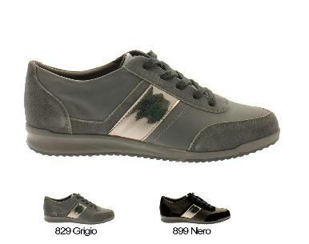
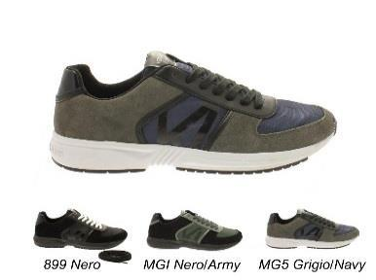
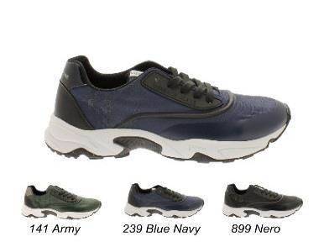
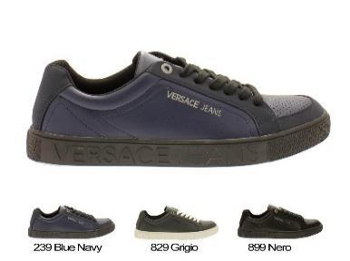
 |  |  |  | 39 | 40 | 41 | 42 | 43 | 44 | 45
YOBSE2 77163 | 77163 | 141 | ARMY | 6 | 13 | 9 | 14 | 2 | 9 | 2 | 55
YOBSE2 77163 | 77163 | 239 | BLUE AVIO | 11 | 20 | 12 | 12 | 22 | 7 | 5 | 89
YOBSE2 77163 | 77163 | 899 | BLACK | 11 | 10 | 19 | 12 | 18 | 27 | 10 | 107
 |  |  |  |  |  |  |  |  |  |  |  | € | 41,50 | €
 |  |  |  | 39 | 40 | 41 | 42 | 43 | 44 | 45
YOBSE3 77164 | 77164 | .003 | WHITE | 3 | 13 | 9 | 14 | 2 | 9 | 2 | 52
YOBSE3 77164 | 77164 | M27 | BLACK-GOLD | 5 | 20 | 12 | 12 | 22 | 7 | 5 | 83
YOBSE3 77164 | 77164 | 899 | BLACK | 1 | 10 | 19 | 12 | 18 | 27 | 10 | 97
 |  |  |  |  |  |  |  |  |  |  |  | € | 62,00 | €
 |  |  |  | 39 | 40 | 41 | 42 | 43 | 44 | 45
YNBSA0 77100 | 77100 | 807 | GRIGIO CHIARO | 29 | 12 | 19 | 38 | 51 | 37 | 23 | 209
YNBSA0 77100 | 77100 | 899 | NERO |  | 2 | 1 | 2 | 12 | 28 | 22 | 67
 |  |  | BLU NAVY |  | 2 | 1 | 2 | 12 | 28 | 22 | 67
 |  |  |  |  |  |  |  |  |  |  |  | € | 45,00 | €
 |  |  |  | 39 | 40 | 41 | 42 | 43 | 44 | 45
YNBSA1 77101 | 77101 | MAQ | GRIGIO-BLUE | 23 | 22 | 34 | 21 | 26 | 32 | 32 | 190
YNBSA1 77101 | 77101 | MF8 | NERO-GRIGIO | 14 | 15 | 24 | 27 | 10 | 20 | 16 | 126
 |  |  |  |  |  |  |  |  |  |  |  | € | 45,00 | €
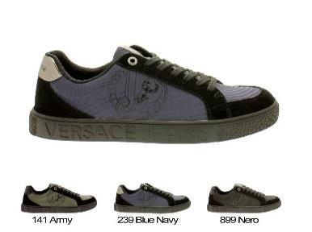
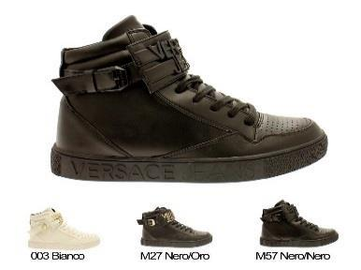
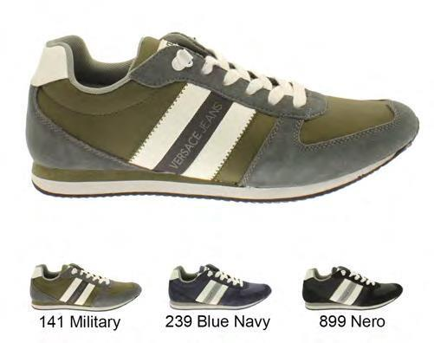
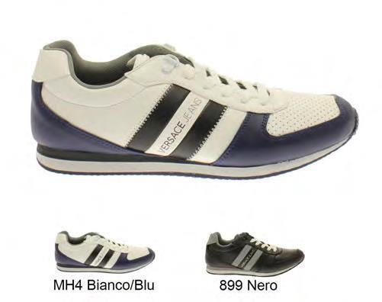
 |  |  |  | 39 | 40 | 41 | 42 | 43 | 44 | 45
YNBSA2 77102 | 77102 | 807 | GRIGIO CHIARO | 12 | 10 | 23 | 22 | 22 | 22 | 12 | 123
YNBSA2 77102 | 77102 | 899 | NERO | 11 | 6 | 12 | 19 | 31 | 22 | 18 | 119
 |  |  |  |  |  |  |  |  |  |  |  | € | 45,00 | €
 |  |  |  | 39 | 40 | 41 | 42 | 43 | 44 | 45
YNBSA3 77103 | 77103 | .005 | GHIACCIO | 20 | 23 | 22 | 22 | 21 | 23 | 22 | 153
YNBSA3 77103 | 77103 | 899 | NERO | 15 | 23 | 21 | 21 | 22 | 21 | 36 | 159
 | 77103 | 239 | BLU NAVY | 15 | 18 | 18 | 19 | 23 | 18 | 23 | 134
 |  |  |  |  |  |  |  |  |  |  |  | € | 45,00 | €
 |  |  |  | 39 | 40 | 41 | 42 | 43 | 44 | 45
YNBSA4 77104 | 77104 | 807 | GRIGIO CHIARO | 24 | 66 | 35 | 47 | 35 | 46 | 8 | 261
YNBSA4 77104 | 77104 | 899 | NERO | 14 | 37 | 37 | 35 | 29 | 30 | 16 | 198
 |  |  |  |  |  |  |  |  |  |  |  | € | 45,00 | €
 |  |  |  | 39 | 40 | 41 | 42 | 43 | 44 | 45
YNBSB1 77105 | 77105 | MFA | BIANCO | 33 | 5 | 16 | 19 | 20 | 18 | 12 | 123
YNBSB1 77105 | 77105 | 899 | NERO | 12 | 14 | 16 | 11 | 15 | 16 | 16 | 100
 |  |  |  |  |  |  |  |  |  |  |  | € | 42,50 | €
 |  |  |  | 39 | 40 | 41 | 42 | 43 | 44 | 45
YNBSB2 77107 | 77107 | 800 | GRIGIO CHIARO | 12 | 12 | 21 | 23 | 32 | 21 | 12 | 133
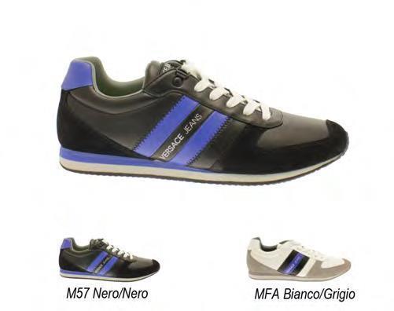
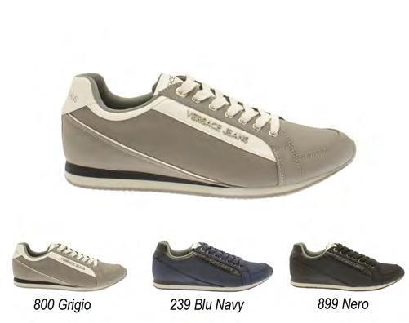
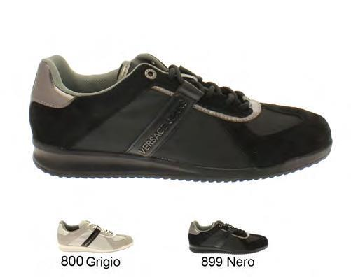
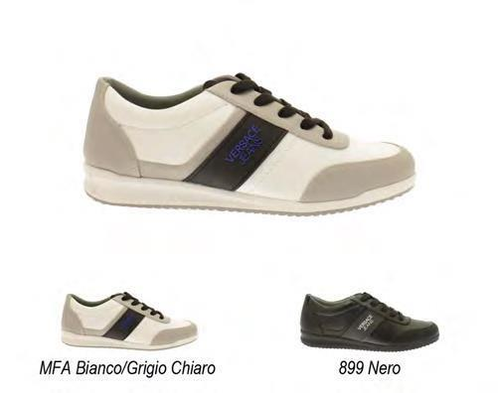
YNBSB2 77107 | 77107 | 240 | NAVY | 12 | 36 | 36 | 36 | 36 | 36 | 12 | 204
 |  |  |  |  |  |  |  |  |  |  |  | € | 42,50
 |  |  |  | 39 | 40 | 41 | 42 | 43 | 44 | 45
YNBSD1 77110 | 77110 | 904 | INDIGO | 11 | 14 | 21 | 12 | 19 | 21 | 22 | 120
YNBSD1 77110 | 77110 | 899 | NERO | 8 | 16 | 24 | 18 | 21 | 18 | 14 | 119
 |  |  |  |  |  |  |  |  |  |  |  | € | 48,00
 |  |  |  | 39 | 40 | 41 | 42 | 43 | 44 | 45
YNBSB2 77107 | 77107 | 807 | GRIGIO CHIARO | 12 | 23 | 25 | 25 | 21 | 21 | 21 | 148
YNBSB2 77107 | 77107 | 899 | NERO | 8 | 32 | 28 | 26 | 24 | 26 | 20 | 164
 |  |  |  |  |  |  |  |  |  |  |  | € | 48,00
 |  |  |  | 39 | 40 | 41 | 42 | 43 | 44 | 45
YNBSD1 77110 | 77110 | 904 | INDIGO | 12 | 23 | 25 | 25 | 21 | 21 | 21 | 148
YNBSD1 77110 | 77110 | 899 | NERO | 12 | 23 | 38 | 26 | 24 | 24 | 21 | 168
 |  |  |  |  |  |  |  |  |  |  |  | € | 46,75
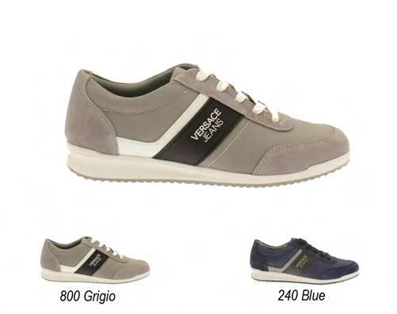
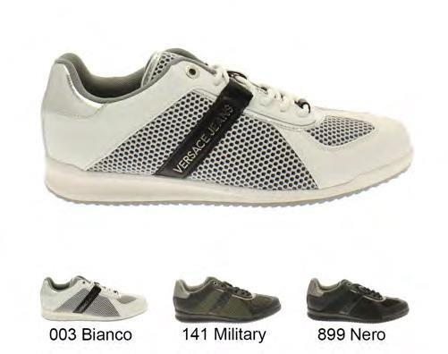
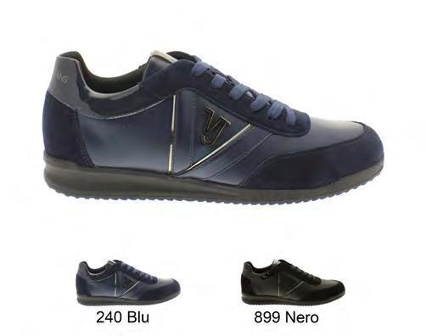
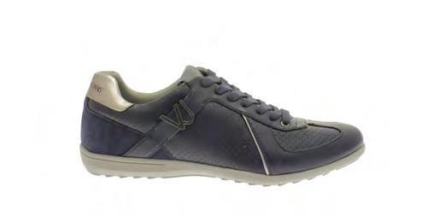
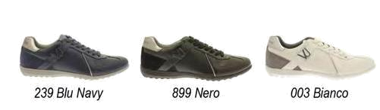
 |  |  |  | 39 | 40 | 41 | 42 | 43 | 44 | 45
YNBSD1 77110 | 77110 | 904 | INDIGO | 21 | 22 | 22 | 34 | 32 | 22 | 21 | 174
 |  |  |  |  |  |  |  |  |  |  |  | € | 46,75 | €
 |  |  |  | 39 | 40 | 41 | 42 | 43 | 44 | 45
YNBSD1 77110 | 77110 | 904 | INDIGO | 42 | 43 | 21 | 32 | 32 | 32 | 21 | 223
YNBSD1 77110 | 77110 | 899 | NERO | 42 | 43 | 18 | 32 | 23 | 23 | 21 | 202
 |  |  |  |  |  |  |  |  |  |  |  | € | 46,75 | €
 |  |  |  | 39 | 40 | 41 | 42 | 43 | 44 | 45
YNBSB2 77107 | 77107 | M27 | NERO-ORO | 18 | 23 | 29 | 36 | 36 | 34 | 30 | 206
 |  | M10 | NERO-ARG. | 19 | 34 | 36 | 34 | 38 | 22 | 32 | 215
 |  |  |  |  |  |  |  |  |  |  |  | € | 62,00 | €
 |  |  |  | 39 | 40 | 41 | 42 | 43 | 44 | 45
YNBSD1 77110 | 77110 | 904 | INDIGO | 42 | 43 | 90 | 32 | 32 | 21 | 43 | 303
YNBSD1 77110 | 77110 | 899 | NERO | 24 | 24 | 32 | 32 | 32 | 24 | 24 | 192
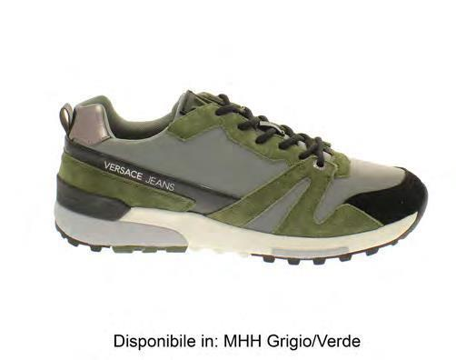
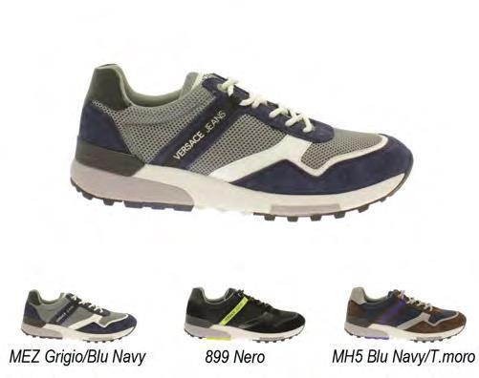
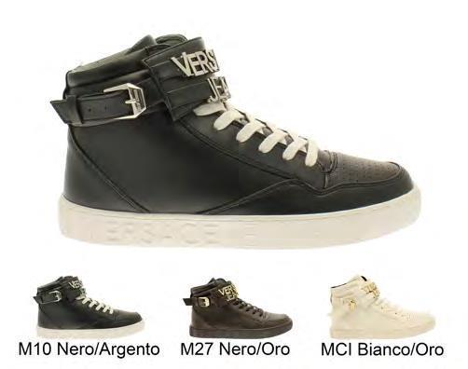

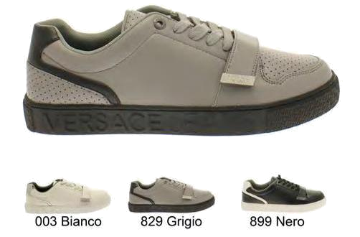 |  |  |  |  |  |  |  |  |  |  |  | € | 50,50 | €
 |  |  |  | 39 | 40 | 41 | 42 | 43 | 44 | 45
YNBSB2 77107 | 77107 | 807 | GRIGIO CHIARO | 50 | 32 | 43 | 32 | 32 | 32 | 41 | 262
 |  |  |  |  |  |  |  |  |  |  |  | € | 56,00 | €
 |  |  |  | 39 | 40 | 41 | 42 | 43 | 44 | 45
YNBSD1 77110 | 77110 | 899 | NERO | 42 | 32 | 32 | 32 | 42 | 33 | 12 | 225
 |  | M53 | BIANCO-NERO | 12 | 26 | 23 | 29 | 32 | 21 | 12 | 155
 |  |  |  |  |  |  |  |  |  |  |  | € | 5100 | €
 |  |  |  | 39 | 40 | 41 | 42 | 43 | 44 | 45
YNBSB2 77107 | 77107 | 807 | GRIGIO CHIARO | 32 | 32 | 34 | 32 | 23 | 23 | 41 | 217
YNBSB2 77107 | 77107 | 899 | NERO | 24 | 24 | 24 | 24 | 24 | 24 | 24 | 168
 |  |  |  |  |  |  |  |  |  |  |  | € | 45,50 | €
 |  |  |  | 39 | 40 | 41 | 42 | 43 | 44 | 45
YNBSD1 77110 | 77110 | 239 | BLU NAVY | 12 | 8 | 8 | 12 | 21 | 12 | 10 | 83
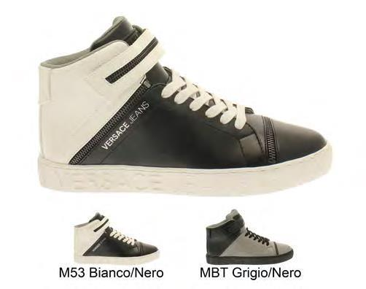
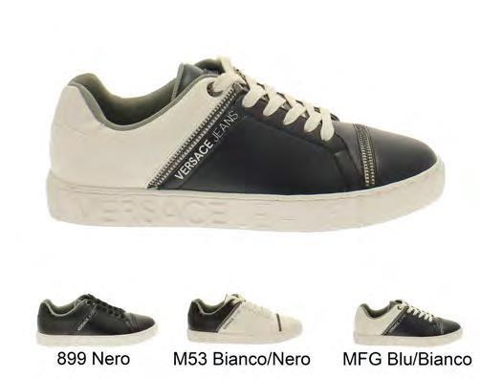
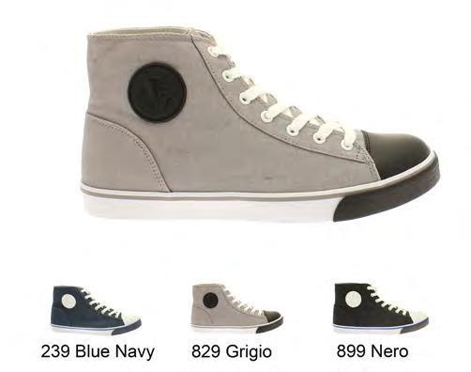
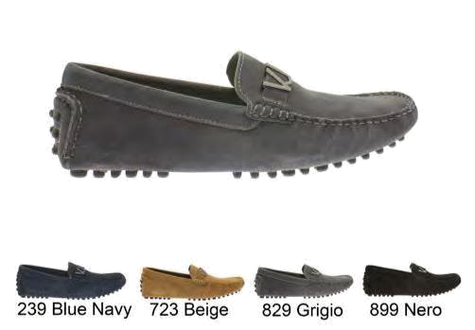 |  |  |  |  |  |  |  |  |  |  |  | € | 42,00 | €
 |  |  |  | 39 | 40 | 41 | 42 | 43 | 44 | 45
YNBSB2 77107 | 77107 | 899 | NERO | 12 | 10 | 12 | 14 | 16 | 14 | 10 | 88
 |  |  |  |  |  |  |  |  |  |  |  | € | 42,00 | €
 |  |  |  | 39 | 40 | 41 | 42 | 43 | 44 | 45
YOBSF1 77165 | 77165 | 899 | BLACK | 12 | 32 | 32 | 35 | 32 | 36 | 12 | 191
YOBSF1 77165 | 77165 | 239 | BLUE-NAVY | 8 | 15 | 19 | 12 | 23 | 27 | 6 | 110
 |  |  |  |  |  |  |  |  |  |  |  | € | 45,50 | €
 |  |  |  |  |  |  |  |  |  |  | 11454
